Two different kind of school gardens:
The school gardens of the parents for producing food for the students: Here manioc
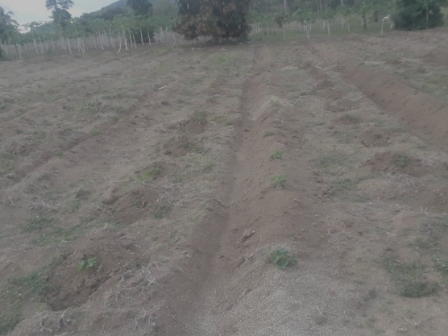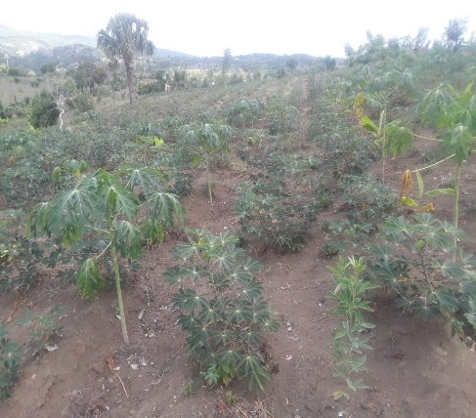
The planted field 2 Months later: the growing plants
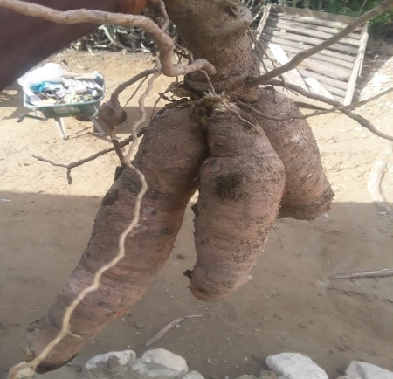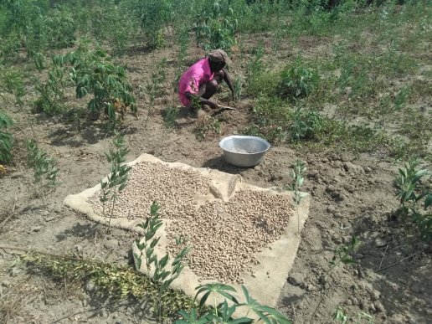
The crop of manioc and Peanuts for preparing peanuts butter
The transformation to bread of manioc and feeding the children in school
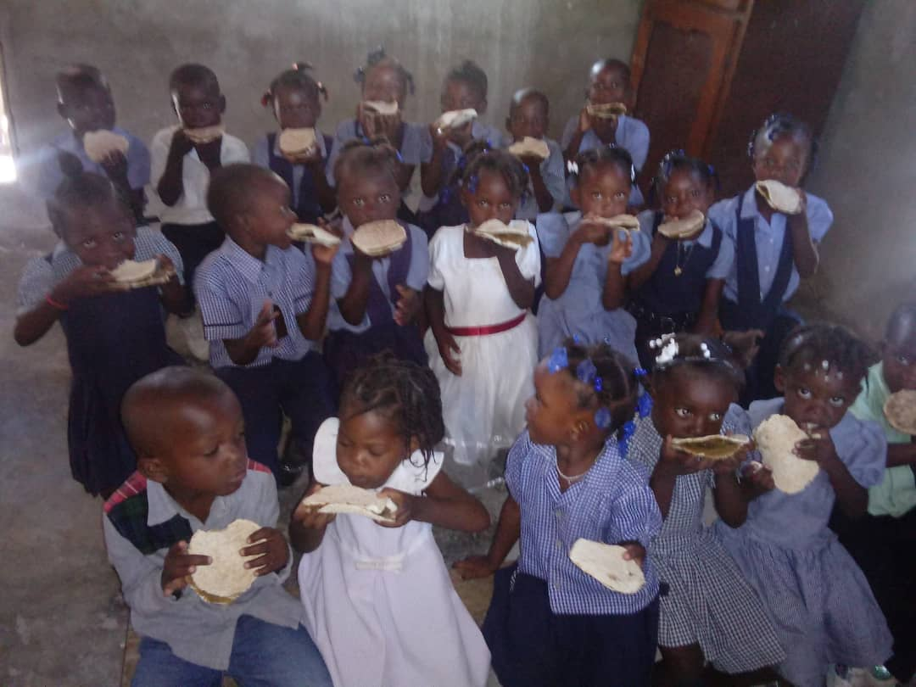
More food production for the school canteen with hot meals:
Maize, millet, different kinds of beans
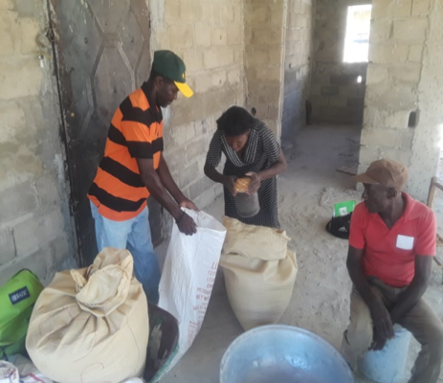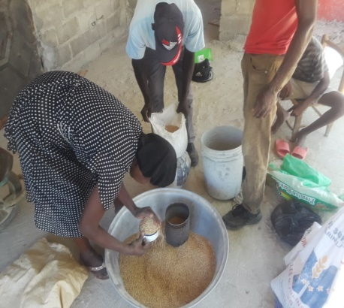
Distribution of seeds different kind ofbeans
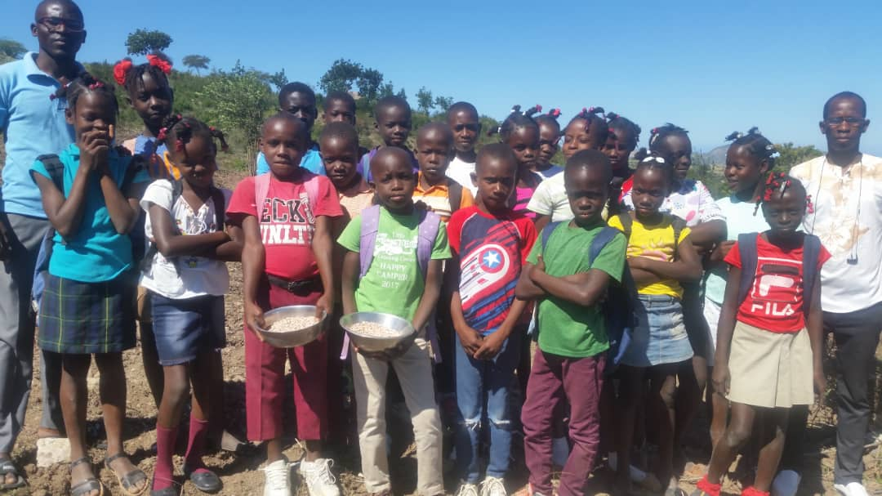
Schoolchildren help the parents to plant beans
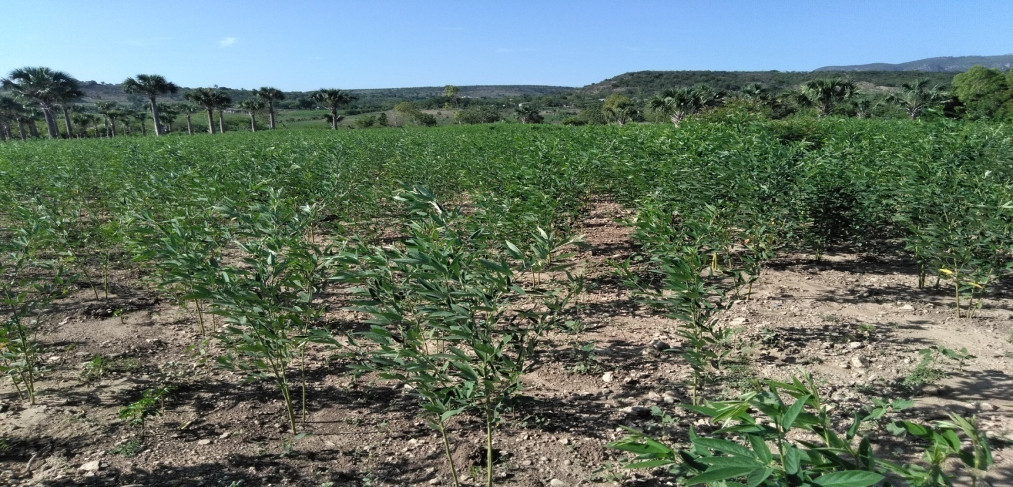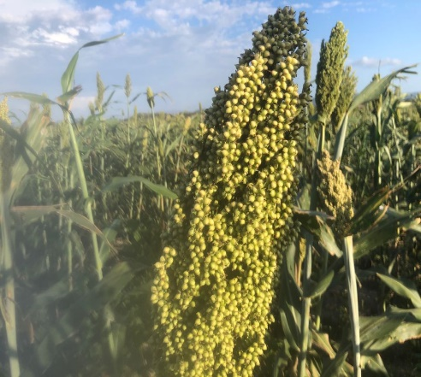
Crop of beans Crop of millet

Teachers receive training in pedagogy and method of how to teach agroecology to primary school students
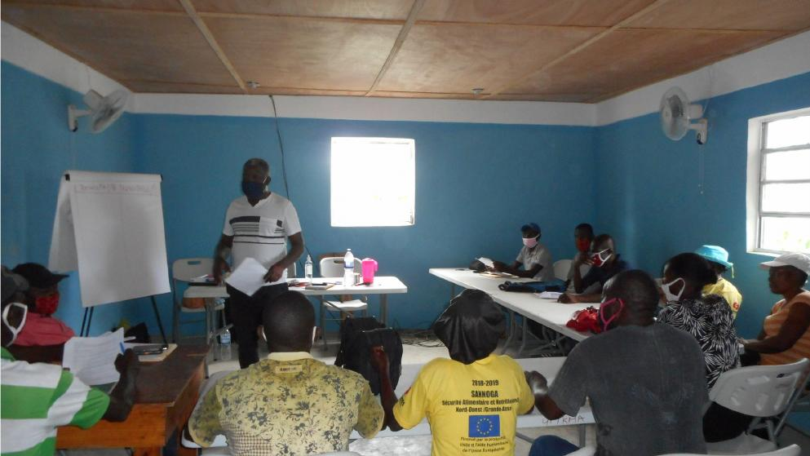

Prepared School gardens of the students Tree nursery
